QUES 1 : Create a Kubernetes cluster using minikube

SOLN:

What is Minikube?
Minikube is a lightweight tool that creates a local Kubernetes cluster on your machine for development and testing purposes. It runs a single-node Kubernetes cluster inside a VM or container.

Install Required Tools
- Minikube
- kubectl (Kubernetes CLI)
- Virtualization enabled (like Hyper-V, VirtualBox, Docker, etc.)
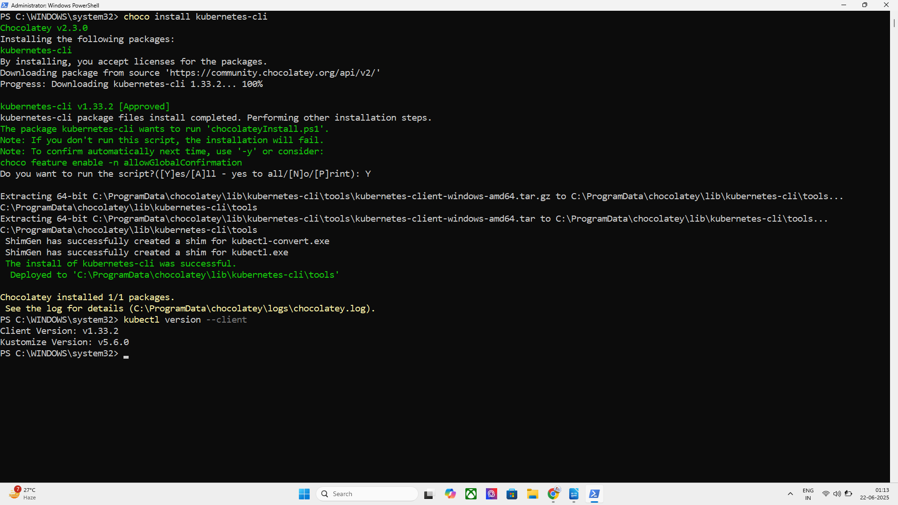

For Windows (Using PowerShell or CMD)

✅ 1. Install kubectl

COMMAND : choco install kubernetes-cli
You need Chocolatey installed.
To verify:
COMMAND : kubectl version --client

2. Install Minikube

COMMAND : choco install minikube
TO VERIFY : minikube version

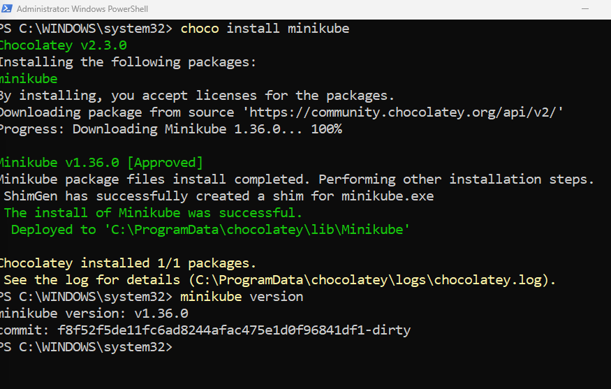
Start Minikube (After Installation)

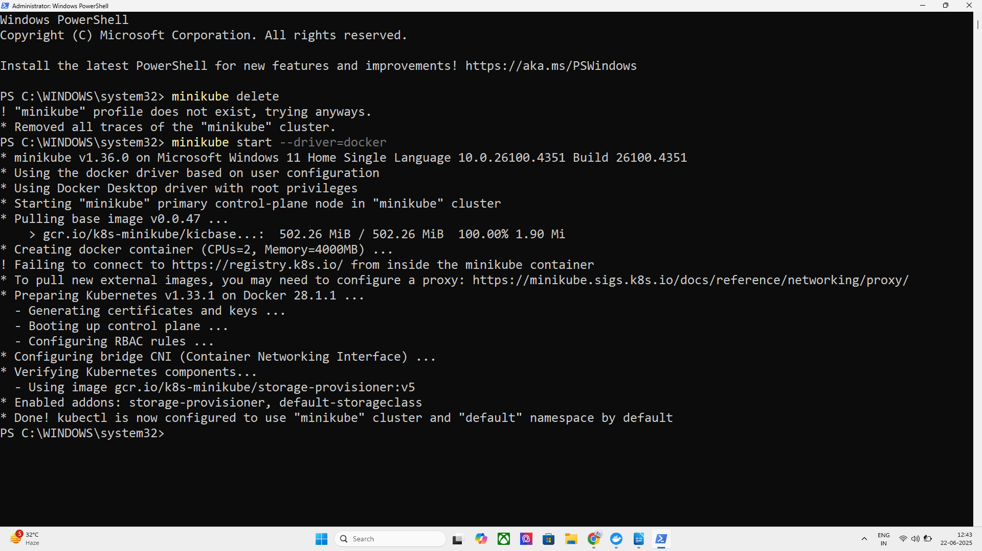
COMMAND : minikube start / minikube start --driver=docker

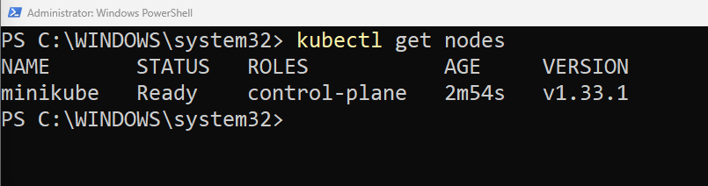
COMMAND TO GET NODES : kubectl get nodes

AND ALSO MINIKUBE IS A SINGLE NODE ARCHITECTURE

TO GET ALL THE PODS THAT ARE RUNNING IN NODE:

COMMAND USED : kubectl get pods -A

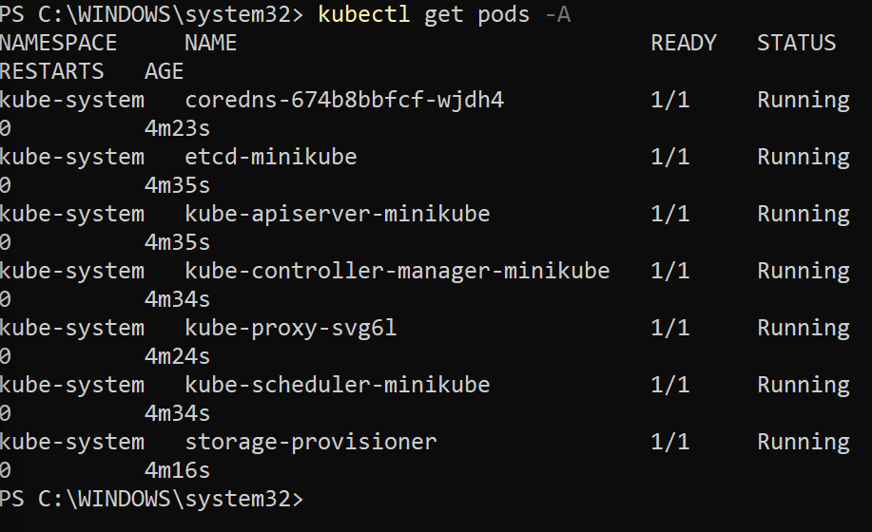
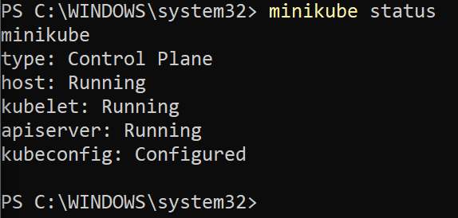
TO CHECK STATUS :
command used :
minikube status

TO OPEN THE DASHBOARD WE USE : minikube dashboard
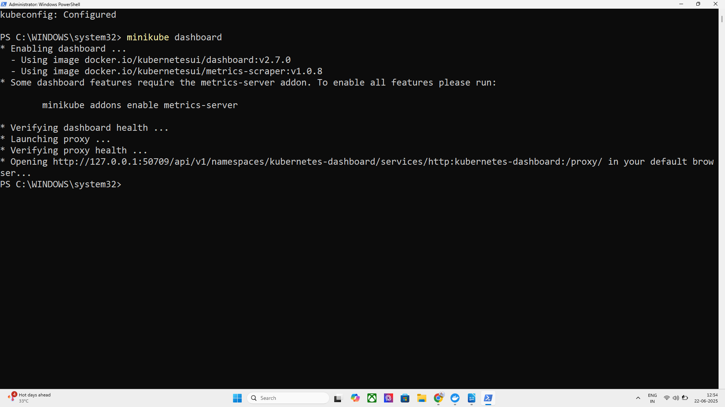
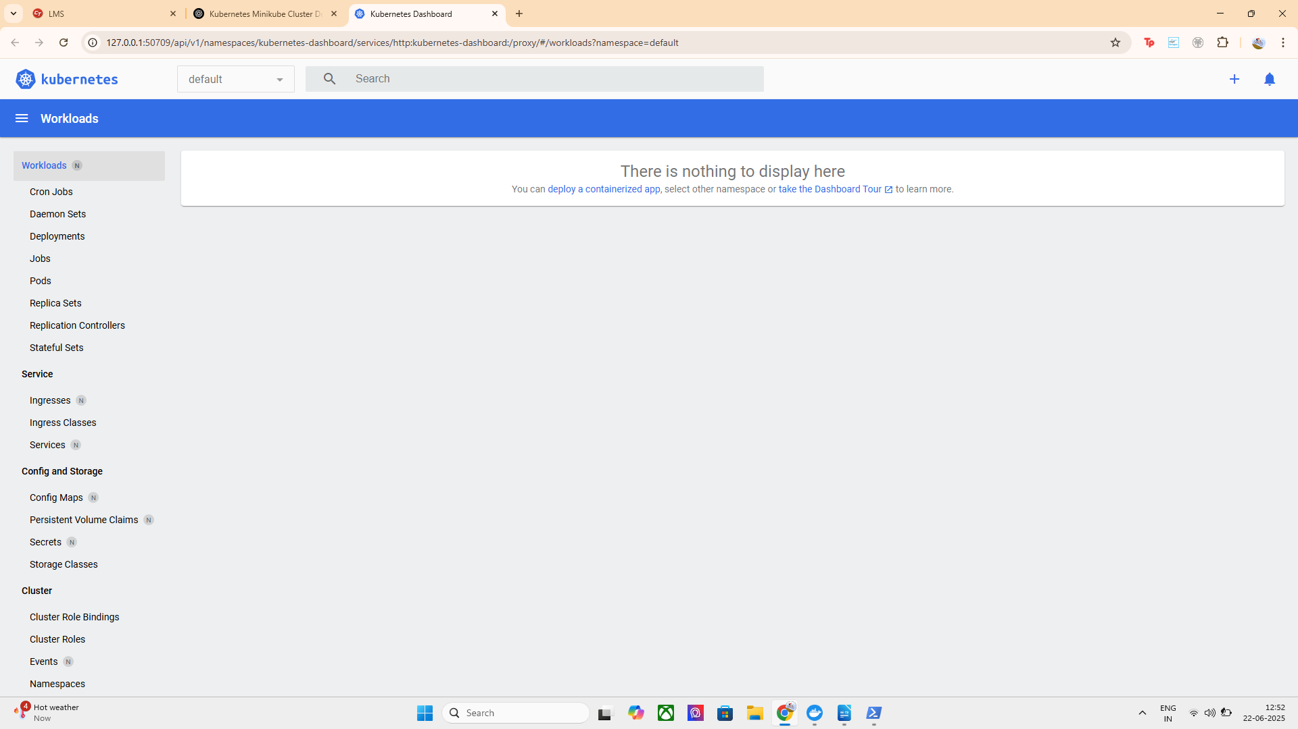

FOR NOW THERE IS NO DEPLOYMENT HENCE DASHBOARD IS EMPTY SO LETS US CREATE A DEPLOYMENT

Lets Deploy a Sample Nginx Application First :

command used : kubectl create deployment my-nginx –image=nginx

This creates a deployment named my-nginx using the official Nginx container image.
- Kubernetes will automatically create a pod running Nginx.
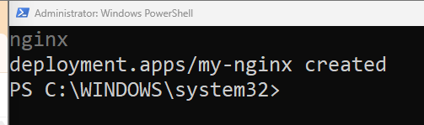

TO GET YOUR DEPLOYMENTS : kubectl get deployments

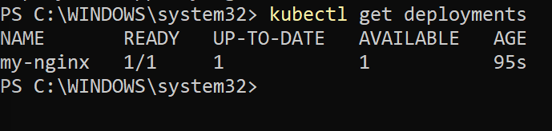

Now Lets Expose the Nginx Deployment

command used : kubectl expose deployment my-nginx --type=NodePort –port=80

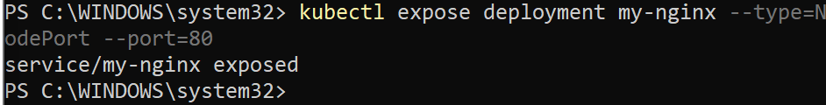

Exposes the Nginx deployment so it can be accessed outside the cluster via a NodePort service.

Command used : kubectl get services

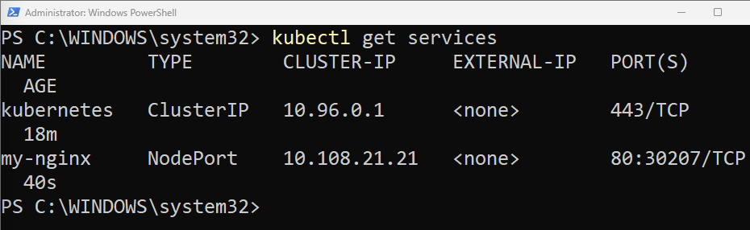

Access the App via Minikube Service

command used : minikube service my-nginx

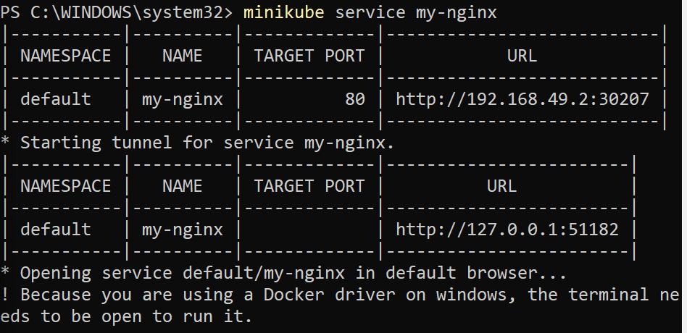
Service running successfully:

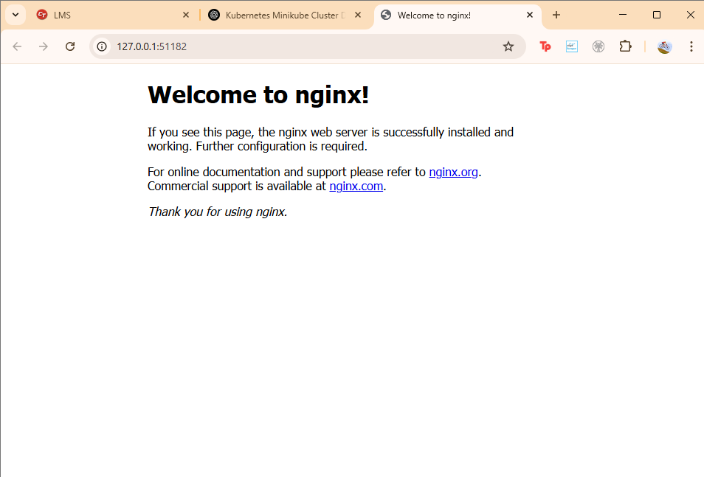
7. View Cluster Resources : kubectl get all

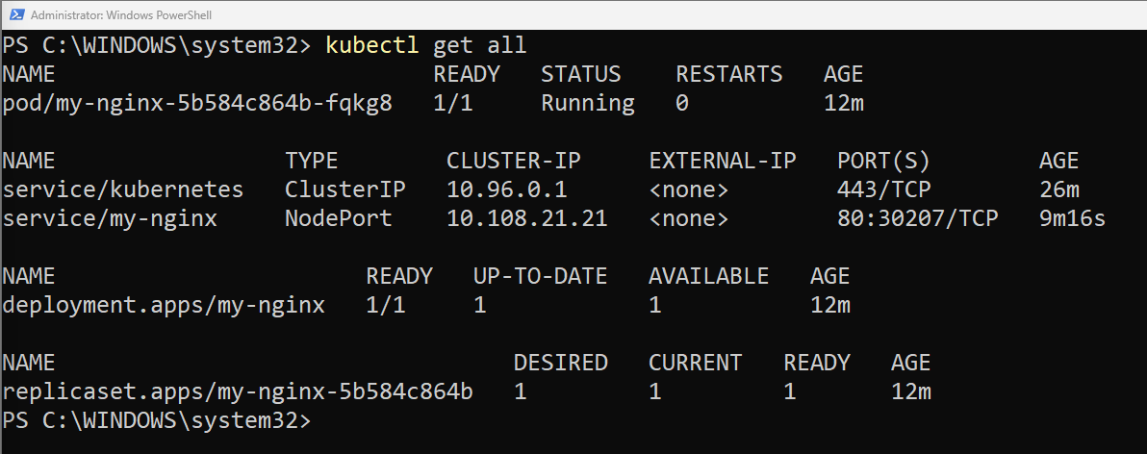
Check Logs of Running Pod :

kubectl get pods
kubectl logs <pod-name>

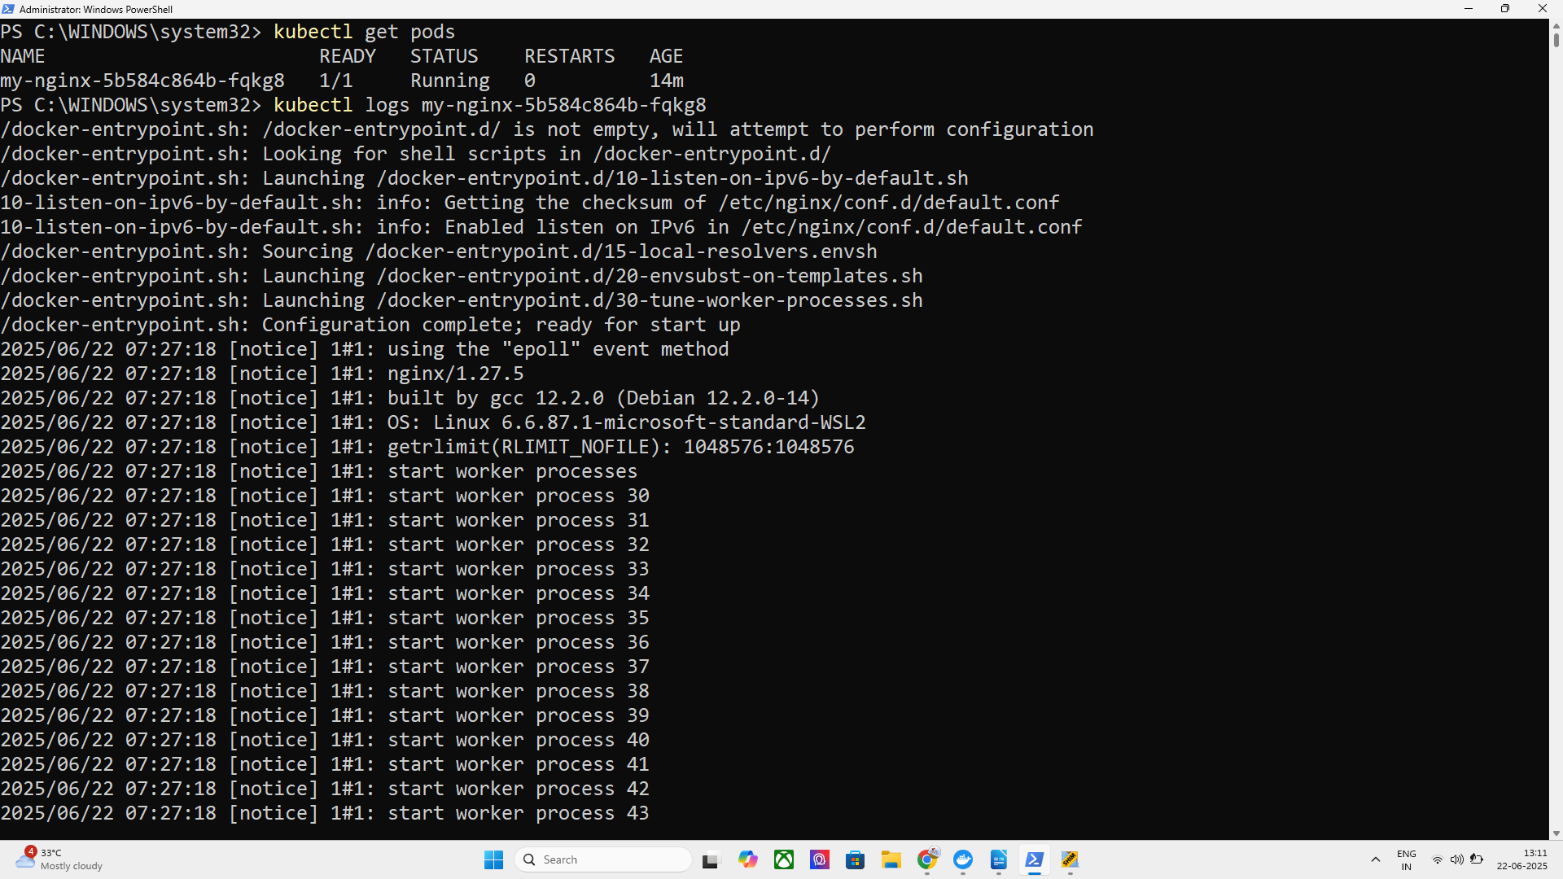
Lets open the dashboard again : Open the Kubernetes Dashboard

Now you can see deployments are ready

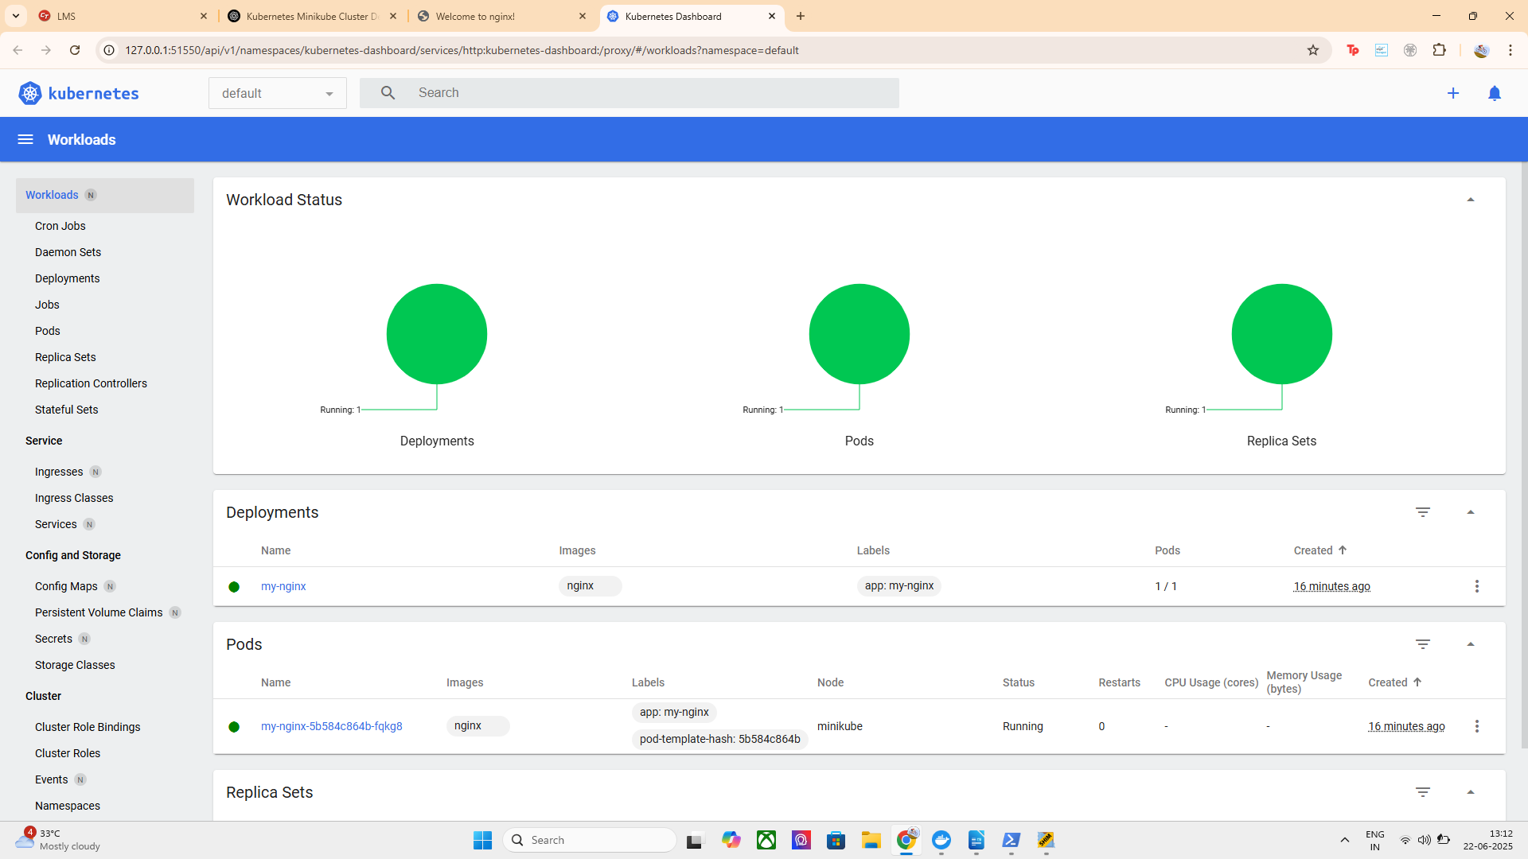
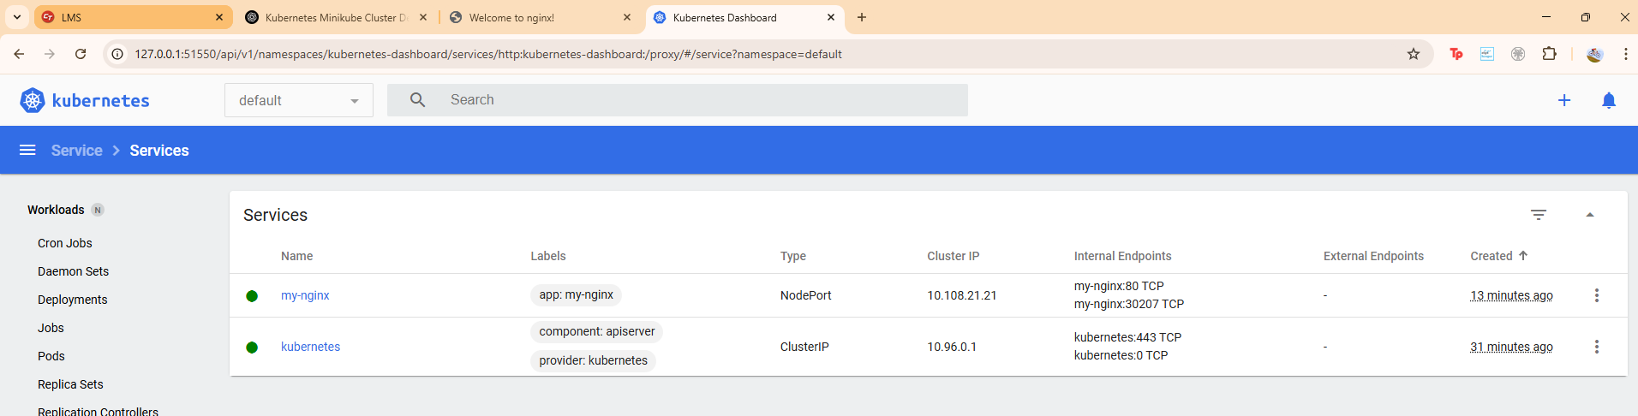
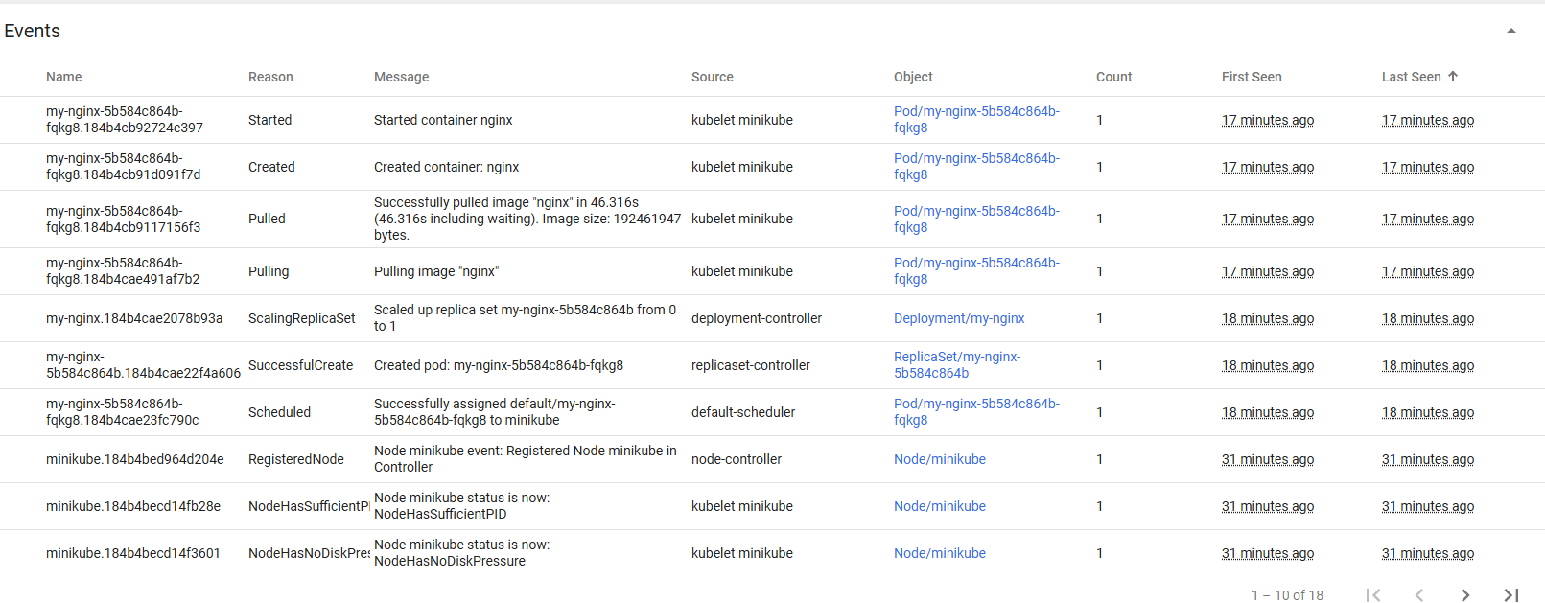
Stop or Delete Cluster :

minikube stop # Stops the cluster
minikube delete # Deletes the Minikube VM and cleans up resources

LETS GET SOME MORE INSIGHTS

BY DEPLOYING SOME

1. Helm Chart

Step 1: Install Helm

For Windows (Using Chocolatey):

choco install kubernetes-helm
helm version or helm --version
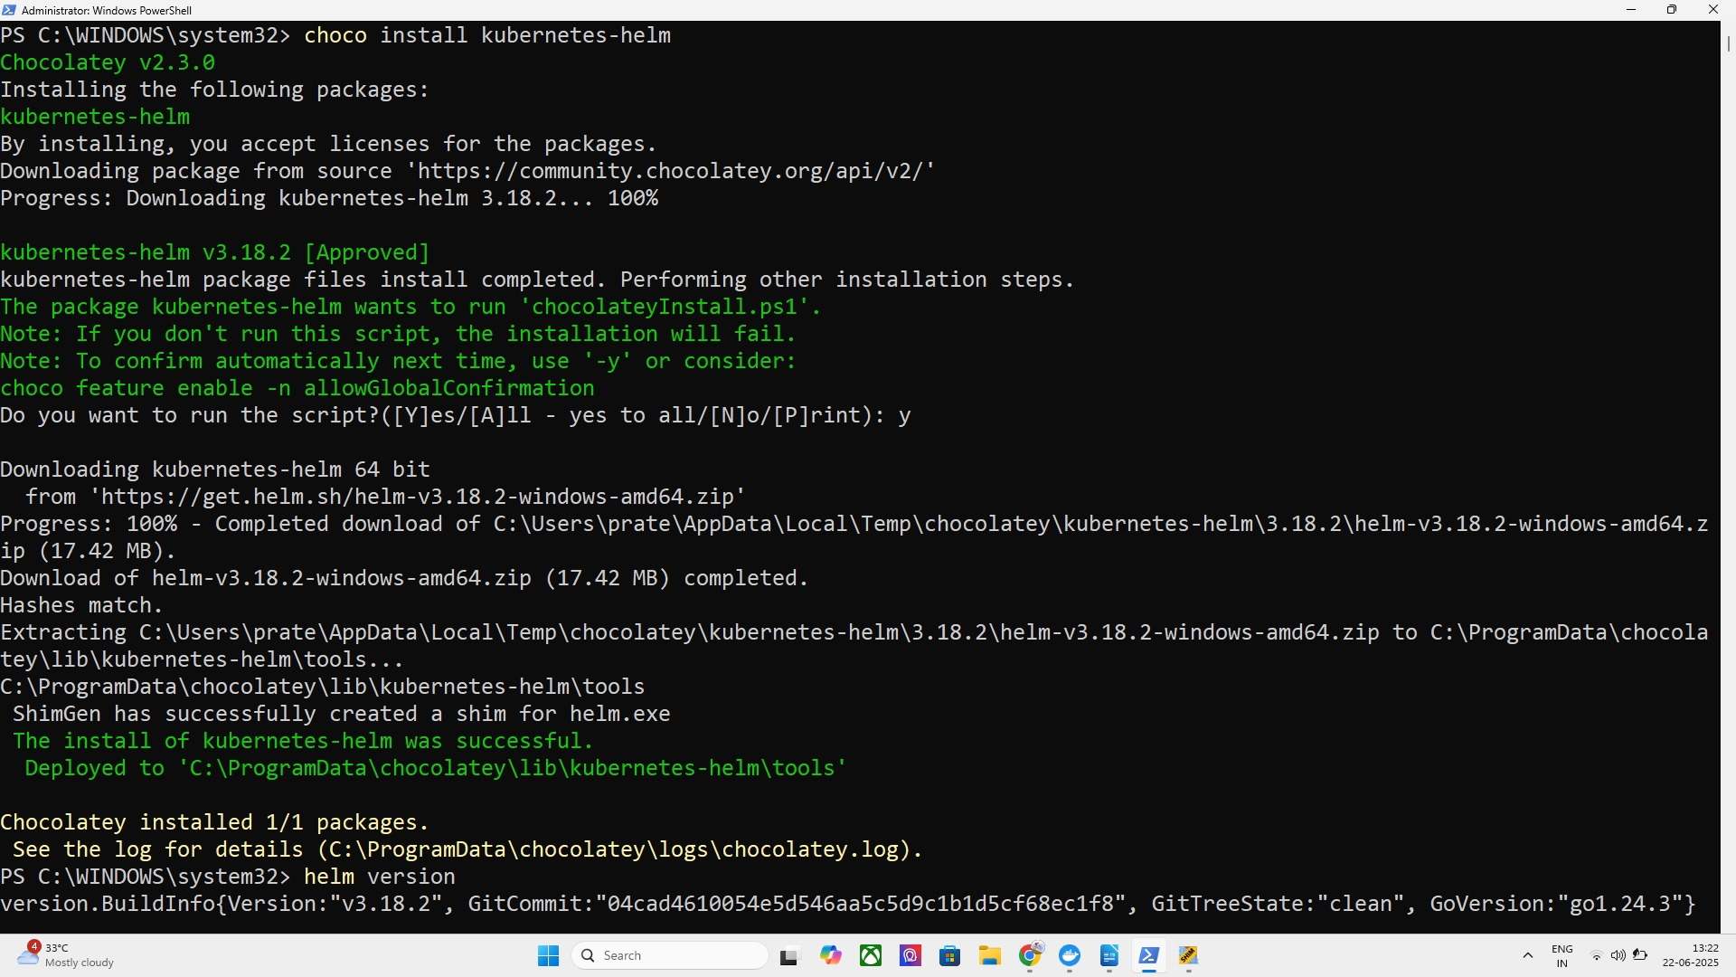
Step 2: Add Bitnami Helm Repository

helm repo add bitnami https://charts.bitnami.com/bitnami

helm repo update

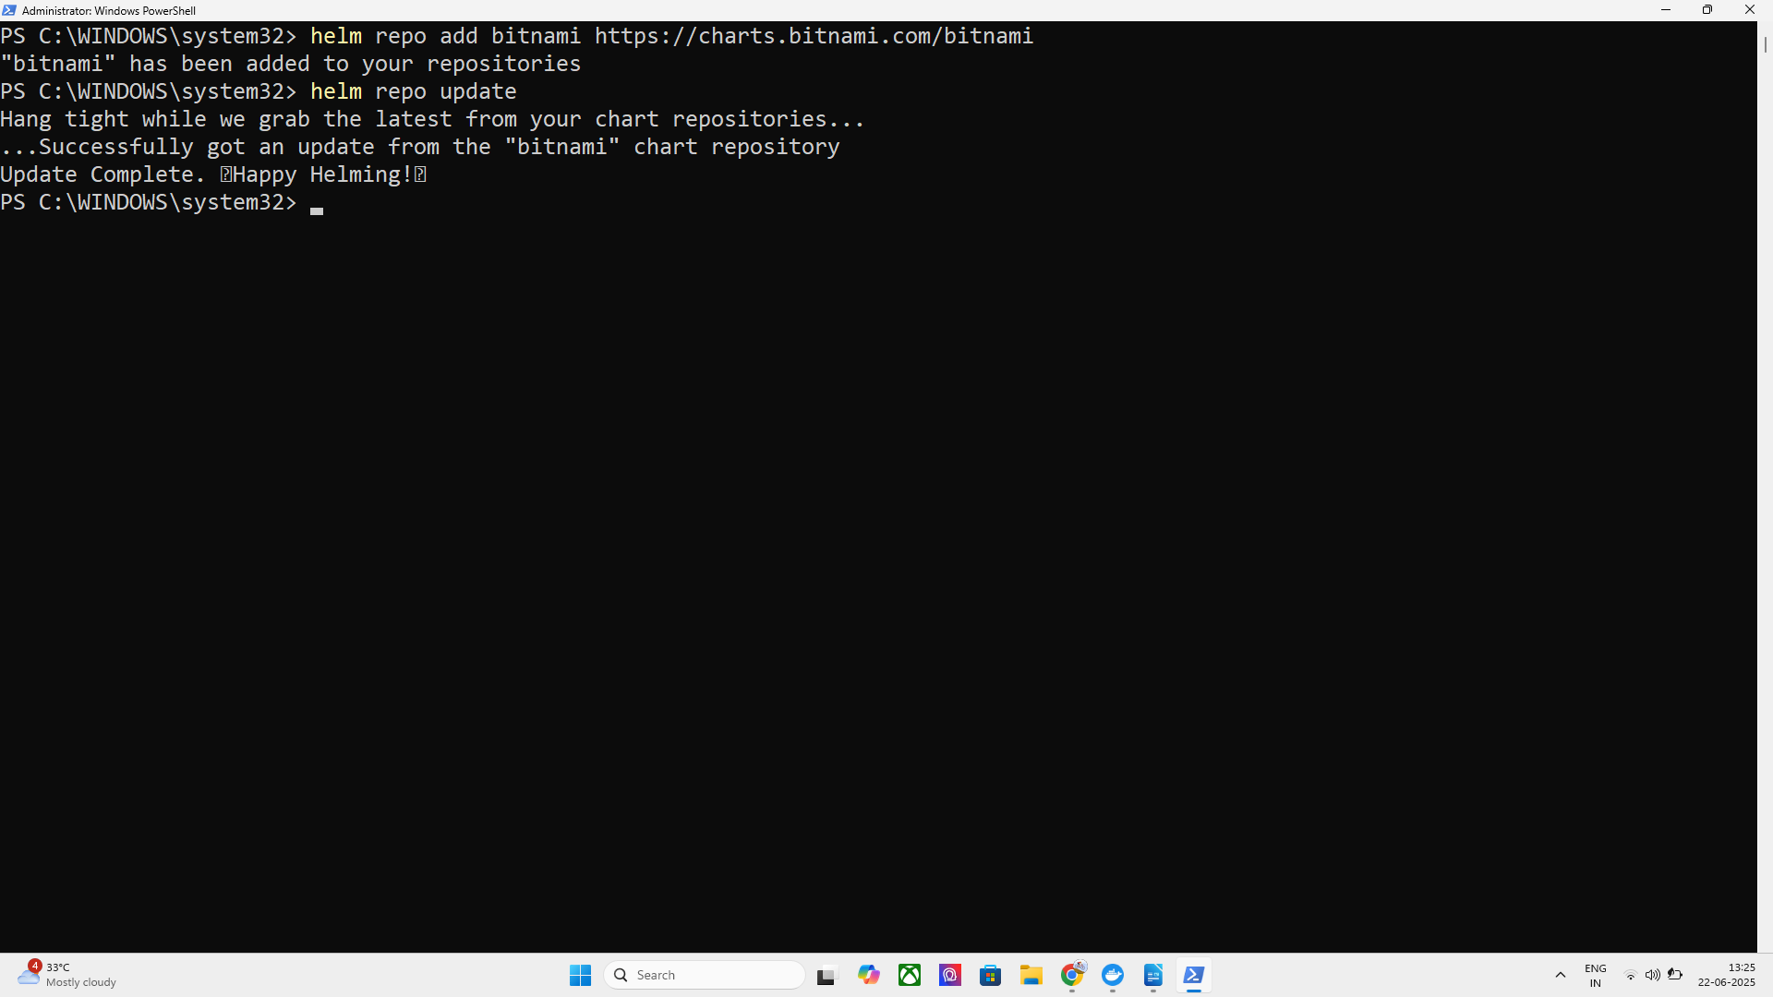

Step 3: Install NGINX via Helm

helm install my-release bitnami/nginx

Step 4: Verify Deployment

kubectl get all

New nginx pod and service formed
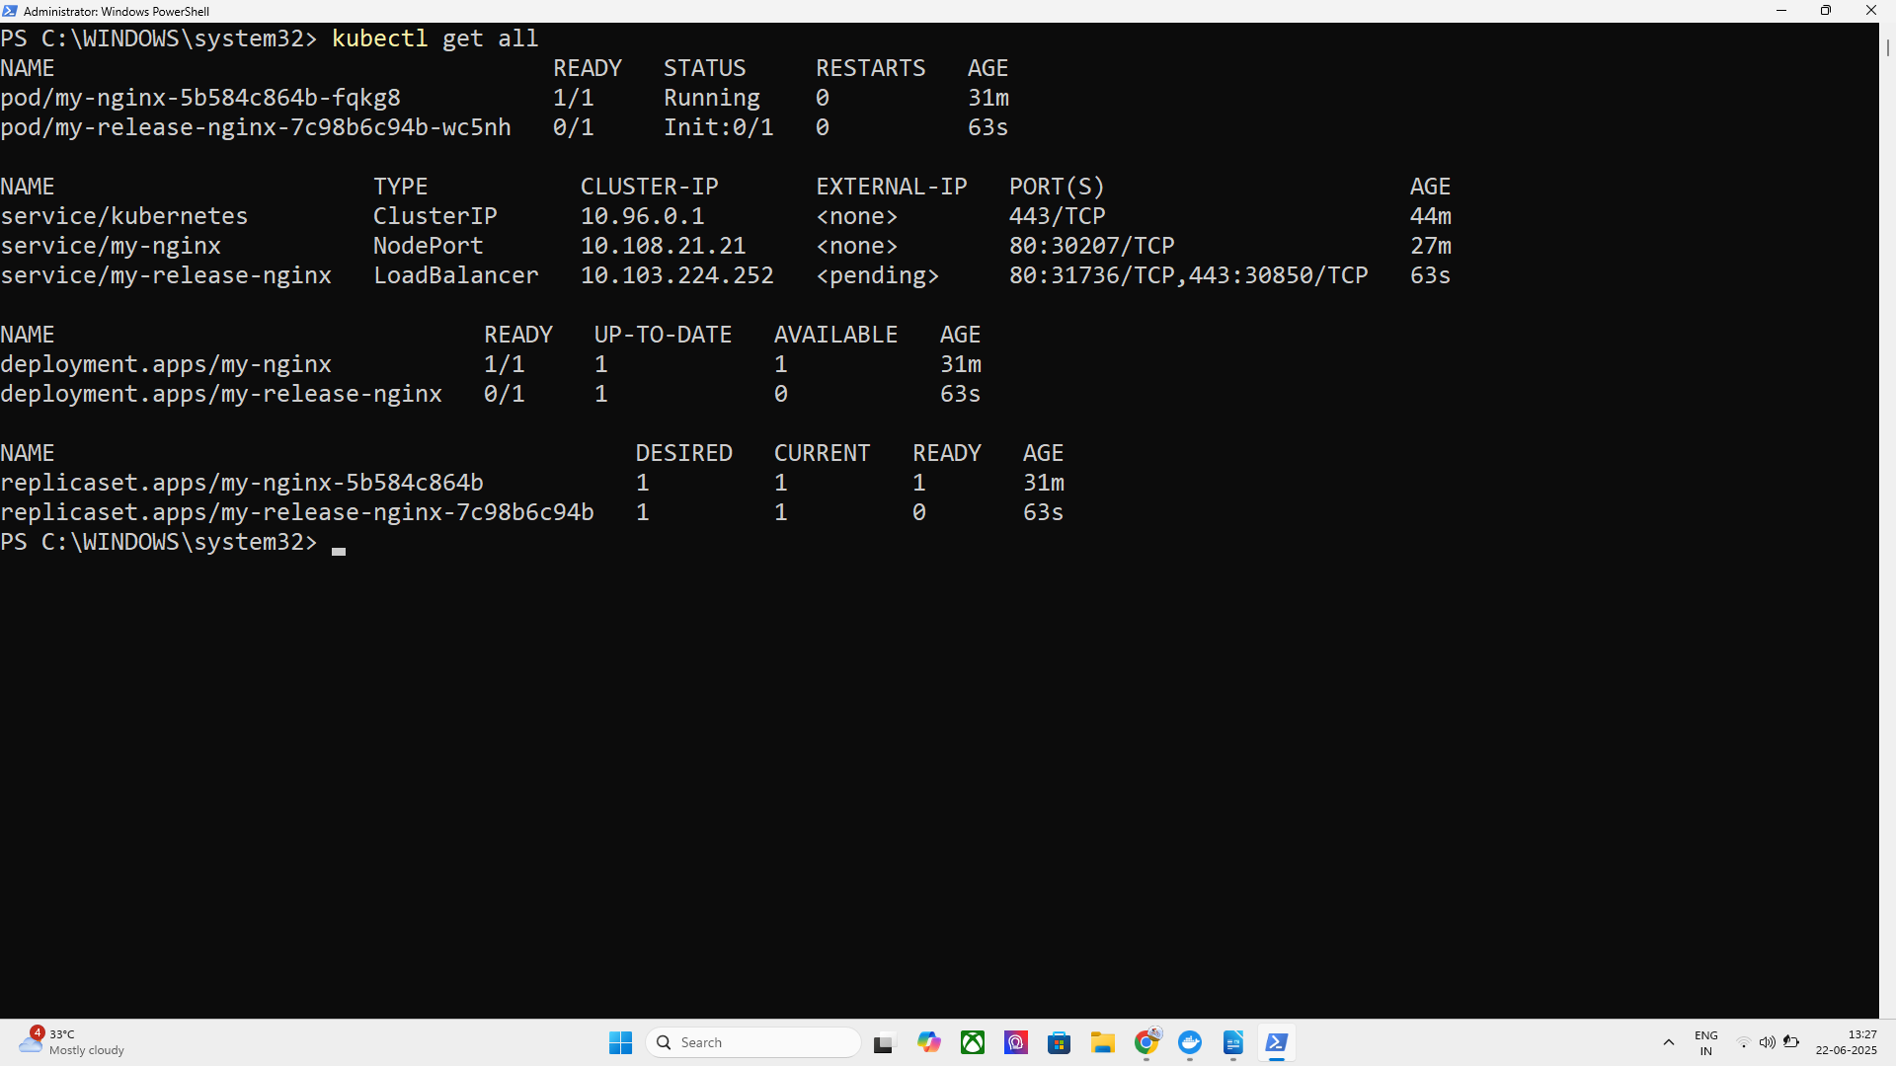

Step 5: Access the App

kubectl get svc

minikube service my-nginx-svc

successfully accessed on local host : http://127.0.0.1:52047

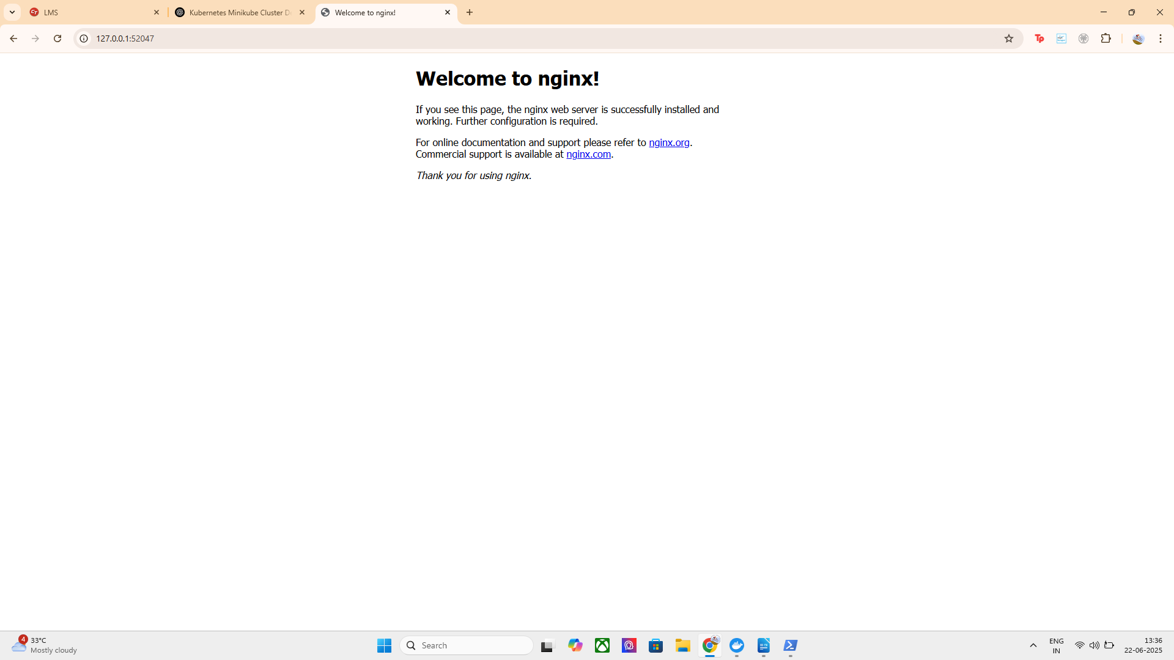
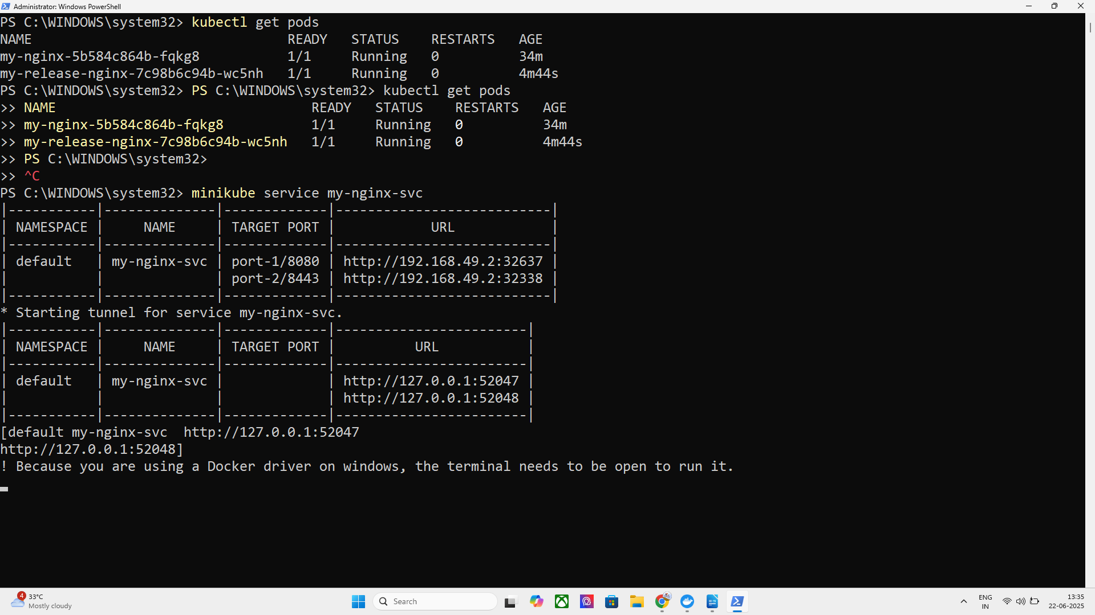

NOW THERE ARE 2 DEPLOYMENTS ONE WITH HELM CHART

What is a Helm Chart?
A Helm Chart is a collection of:
- Kubernetes YAML files
- Templates
- Predefined configurations
That together automate the deployment of a complete application

Why It's Powerful
Instead of writing multiple YAML files (for Deployment, Service, ConfigMap, PVC, etc.), you:
- Run one command
- Helm installs the app with best practices
- You can customize it later with --set or values.yaml

Example: What Happens When You Run This?

helm install my-release bitnami/nginx
You are telling Helm:
- Fetch the NGINX chart from Bitnami's repo
- Install it in your cluster
- Use default settings unless overridden
- Name the release my-release

